**Drawing cytoplasm**

If you look at cells with a light microscope, this is what you may see.

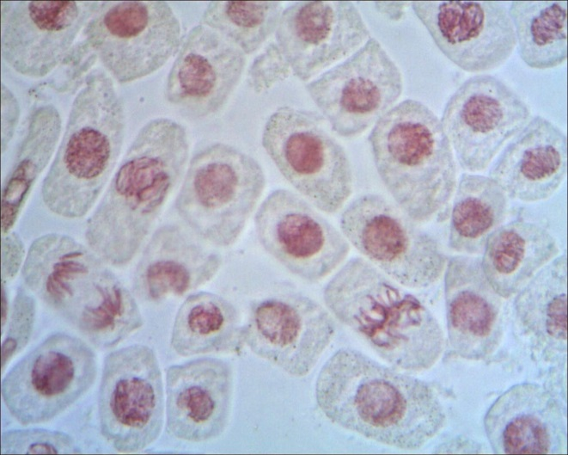

nucleus

cytoplasm

**To discuss**

Imagine you could zoom in to see the cytoplasm of one cell hundreds of times more closely.

What would you see?

**To do**

Draw a diagram of what you think you would see.

Add labels to your diagram.

*Biology > Big idea BCL: The cellular basis of life > Topic BCL1: Cells > Key concept BCL1.4: Diffusion and the cell membrane*

|  |
| --- |
| **Response activity** |
| **Drawing cytoplasm** |

**Overview**

|  |  |
| --- | --- |
| Learning focus: | Molecules move through the cell cytoplasm by diffusion, and some molecules can enter and leave a cell by diffusing through the cell membrane. |
| Observable learning outcome: | Recall that substances are made of particles that move and collide randomly all the time. |
| Activity type: | Discussion, modelling |
| Key words: | cell, cytoplasm, diffusion, particle |

This activity can help overcome students’ misunderstandings about the particulate nature of cell cytoplasm through drawing and group discussion. It can be used in response to the following diagnostic question:

* Diagnostic question: Cytoplasm – a particle model

**What does the research say?**

Johnson (1998) summarises research in which it was found that students have various ways of thinking about substances and what they are made up of at the sub-microscopic level, including:

* that substances are continuous and are not made up of (or do not contain) particles (incorrect);
* that there are particles *in* the continuous substance – i.e. the substance is between the particles (incorrect);
* that particles *are* the substance – i.e. the substance is made up of particles (correct).

Those students who did talk about particles showed very little appreciation of the intrinsic, random movement of particles. In addition, they commonly had misunderstandings about the spacing between the particles of a substance in the liquid state – typically choosing to depict the particles as too far apart, somewhere between that of the solid and gas states. This misunderstanding could be introduced or reinforced by textbook diagrams in which the spacing is shown incorrectly.

Odom (1995) has defined a list of knowledge statements required for understanding diffusion in the context of cells, which begins with the following three ideas:

1. All particles are in constant motion.
2. Diffusion involves the movement of particles.
3. Diffusion results from the random motion and/or collisions of particles (ions or molecules).

…as pre-requisites for the development of understanding that diffusion is the net movement of particles as a result of a concentration gradient.

A number of researchers have described constructivist approaches that enable students to build their own explanations of diffusion, which may help to develop students’ understanding and overcome misconceptions, including group discussion (Christianson and Fisher, 1999) and drawing (Wilkerson-Jerde, Gravel and Macrander, 2015).

**Ways to use this activity**

Students should complete this activity in pairs or small groups. The focus of the activity should be on group discussion to reach a consensus on what the diagram should look like. It is through the discussions that students can check their understanding and develop their explanations. Listening in to the conversations of each group will often give you insights into how your students are thinking.

Alternatively, students could be asked, individually, to draw what they think they would see if they could zoom in to the cytoplasm. In groups, the students’ diagrams could be ‘peer assessed’, with an emphasis on small group discussion to provide constructive feedback rather than simply criticising or assigning a score.

The quality of the discussions can be improved with a careful selection of groups; or by allocating specific roles to students in the each group. For example, you may choose to select a student with strong prior knowledge as a scribe, and forbid them from contributing any of their own answers. They may question the others and only write down what they have been told. This strategy encourages contributions from more members of each group.

After their discussions, each group should be prepared to report the key points of their discussion to another group, or to the class.

**Equipment**

For each pair/group:

* pencils
* spare paper (if not drawing on the worksheet)

**Expected answers**

Whilst there will be great variation in what students draw, there are two key questions to ask about the diagrams:

1. Has the student attempted any representation of particles in their diagram?
2. Has the student included any indication that the particles are moving in their diagram?

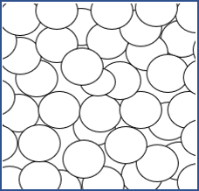Ideally, students will draw something resembling the diagram on the right. They may label the circles as “particles” or “molecules”, or as “cytoplasm particles/molecules” (which is acceptable at this level). More able students may shade some of the circles in different colours to indicate that there are different substances within the cytoplasm, and may label differently-coloured circles as “water”, “sugar”, and so on. Indications of movement may include arrows or movement lines.

**Acknowledgments**

Developed by Helen Harden and Alistair Moore (UYSEG), adapted from an idea by Philip Johnson (School of Education, University of Durham).

Images: cellimagelibrary.org/Shoba Shanti (43552)

**References**

Christianson, R. G. and Fisher, K. M. (1999). Comparison of student learning about diffusion and osmosis in constructivist and traditional classrooms. *International Journal of Science Education,* 21(6)**,** 687-698.

Johnson, P. (1998). Progression in children's understanding of a basic particle theory: a longitudinal study. *International Journal of Science Education,* 20(4)**,** 393-412.

Odom, A. (1995). Secondary & college biology students' misconceptions about diffusion & osmosis. *The American Biology Teacher,* 57(7)**,** 409-415.

Wilkerson-Jerde, M. H., Gravel, B. E. and Macrander, C. A. (2015). Exploring shifts in middle school learners' modeling activity while generating drawings, animations, and computational simulations of molecular diffusion. *Journal of Science Education and Technology,* 24(2)**,** 396-415.